Getting Started with Docker, Kubernetes and Google Kubernetes Engine

Why do we need Docker?

To understand the need for Docker, we will look at a simple scenario. You have a close friend of yours in your operations team and you'd want to quickly deploy an application. You go to him and say, I would want to deploy an application. He asks you, "Hey, what's your Docker image?"

and you give the Docker image to him and he says, "I'll just run this command."

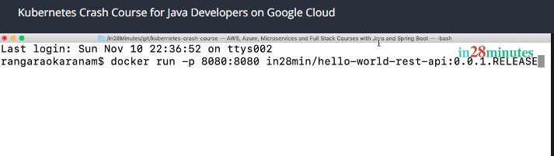

And presses Enter. Within a few seconds, you would see the magic unfold.

You are seeing an application being deployed and if you launch up the URL in the browser, you'll see that the application is up and running within 15 seconds flat.

Now, think about this. Your friend from the operations team did not ask you, "Hey, what language did you build the application with?" He did not ask you, what frameworks you used. He did not ask you, what is the operating system where your application should be deployed on. He did not ask you, what the configuration that your application needs. The thing is, he doesn't really need all that. That's what Docker enables. A developer builds an image, and you can run the same image wherever a container runtime is installed. You can run it on your local machine, in your enterprise datacenter, or in the cloud. Docker enables standardization of how you package and deploy your application irrespective of the language or framework which is used to build the application or the platform where you would want to deploy the application to. Now, you guys are really really happy with Docker and you keep the application running with Docker.

Now, a couple of days later, you go to your friend in the operations team and now ask, "Hey, do you know if my application is still running?

I'd want it to be always running and by the way, I'm expecting a lot of load this weekend. So, I'll want to be able to increase the number of instances whenever there is a lot of load." And also, you say, "There are a number of other applications coming up very very soon. I'd want to be able to deploy and manage all that."

Now, your operation team’s friend gives up. He says, "No, that's not what Docker does." So, you go ahead, research and find out the brand-new tool out there in the market, Kubernetes.

So, you are now the expert on Kubernetes. You have created an amazing Kubernetes cluster, which is nothing but a group of servers that are managed together, and you are now connected to the cluster and it's your friend's turn to specify the requirements right now. He says, "I'd want to quickly deploy an application with this specific image." friend's turn to specify the requirements right now. You say, "Oops! That easy. I just need to run a simple command and you are there.

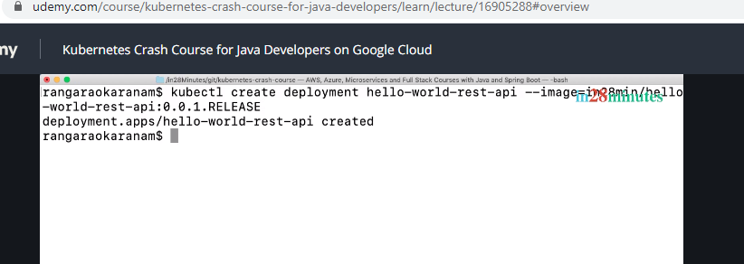

And by the way it's not just one command. Actually, there are two commands that I would need to run to actually deploy an application and make it available to you."

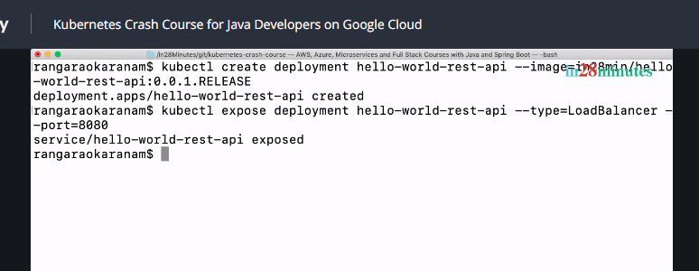

Now, your friend tells you, "Hey, I could have done this in Docker with one command. Kubernetes makes it complex.

You are executing two commands to actually expose a deployment."

Now, you tell him, "Hey, there is a lot of power to what we are doing. Wait and see."

So, you go to the browser, type in a URL, and show him, "Hey, see this. The application is live within 15 seconds."

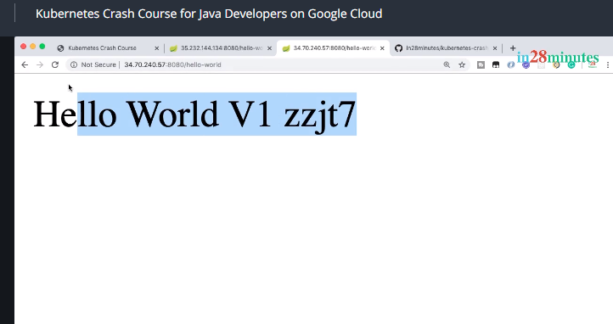

You ask him now, "What more do you want?" Your friend says, "I want three instances." You say, "I'll just run one more command."

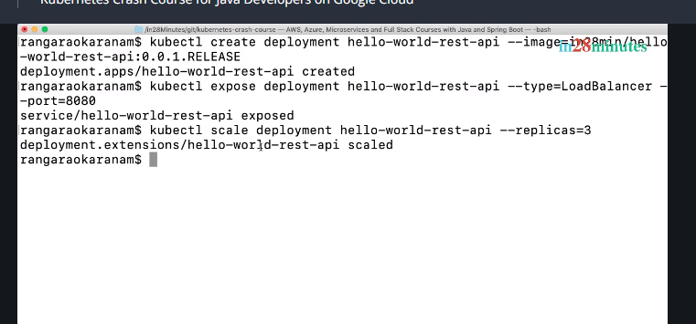

And within 10 seconds, you would see that there are a few more instances coming in.

You can see that there are new instances because this last five digits are changing. These last five digits indicate which instance the response is coming back from

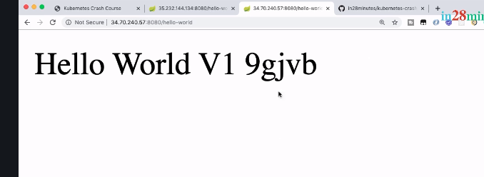

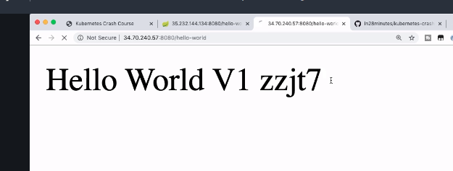

We are getting responses back from different different kinds of instances and you can also see that the load balancing is happening automatically. The load is being distributed among different instances which are present in there.

So, you tell him, "Hey, see the magic in Kubernetes. With just three commands, we were able to actually create multiple instances of an application and also do load balancing."

Now, your friend is still not satisfied. He says, "I would want these instances to be running all the time. Even if one of the containers fail, even if one of the instances goes down, I would want other instances to come up immediately." And you tell him, "Hey, watch this.

I'm executing another command. I'm actually deleting one of the instances right now

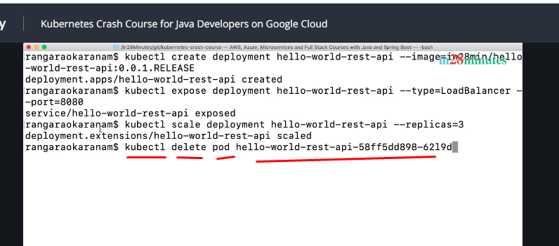

and let's keep refreshing."

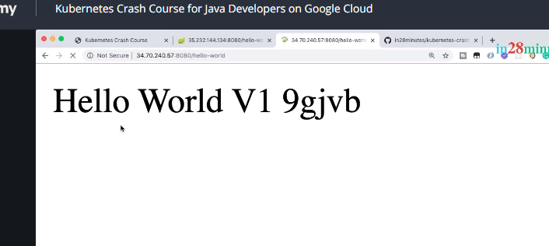

You can see that the application does not go down, even if one of the instances goes down and you'd see that within 10-15 seconds, another instance of the application comes up.

You don't really need to worry about monitoring the application. Kubernetes does it for you.

You told Kubernetes that I need three instances, come what may, Kubernetes will try to ensure that there are three instances always running. Even if one of the instances goes down. Kubernetes does all it can do to bring another instance up. Within a few seconds, you'd see that the third instance is up and running as well. And your friend has one last request. He says, "I would want to increase the number of instances when there is more load. During the weekend, I'm actually expecting a lot of load. But thereafter, I think the load would immediately go down and also during the day, I'll have a lot of load and during the evening, there will not be any load at all and I don't want to manually increase the number of instances and decrease the number of instances." You execute another instruction to auto scale and say, okay, done. I've executed the command to do that.

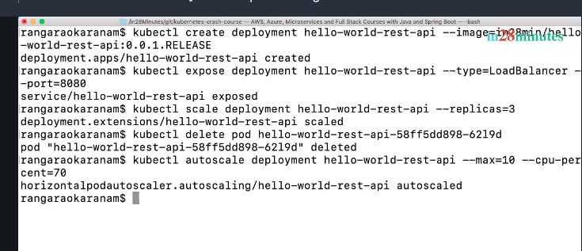

Right now, we can go up to a max of 10 instances, but you can quickly change that whenever you'd want to. He's amazed with all the power of Kubernetes and he says, "One more question please, I have one more requirement.

I would want to make a new release without anything going down. I’d want to go from 0.0.1 release of the application to 0.0.2 release of the application without anything going down."

You tell him, "Hey, it's a little bit more complex than what we have been doing until now, but it's not impossible." You quickly go ahead, edit your deployment, you add a simple line of code in here saying, minReadySeconds is, you say, 15 and say,

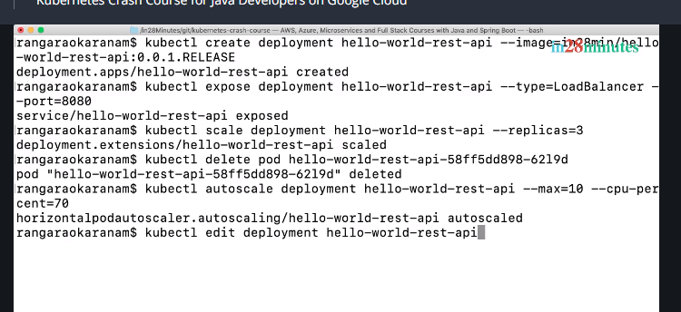

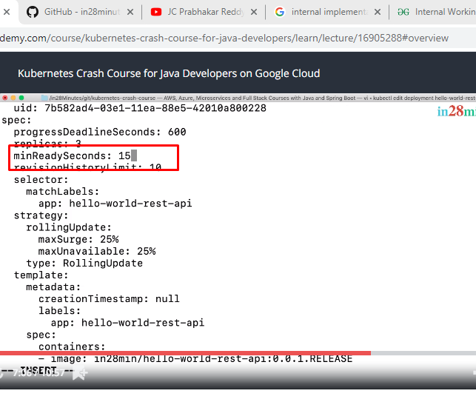

And you'd save this and you tell him, "I have a solution right now which works for 90 percent of the scenarios." and you go ahead and execute the last command to go to the new release, which is 0.0.2.RELEASE.

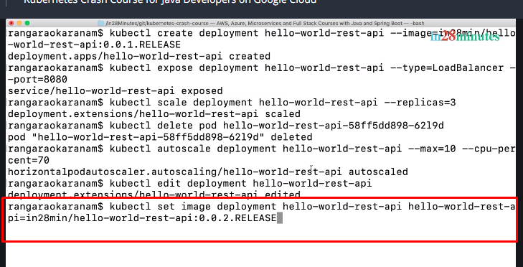

And you would see when the whole thing happens, that the application remains up and running.  So now, V1 is live, that's the only application which is running right now and you can see that the application is still up and running and within a few seconds, you would see that V2 is live and now load is shifting between V1 and V2.

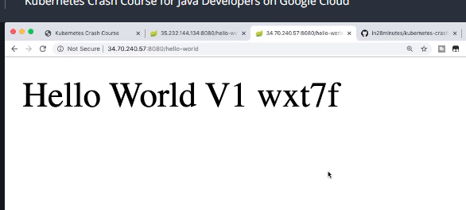

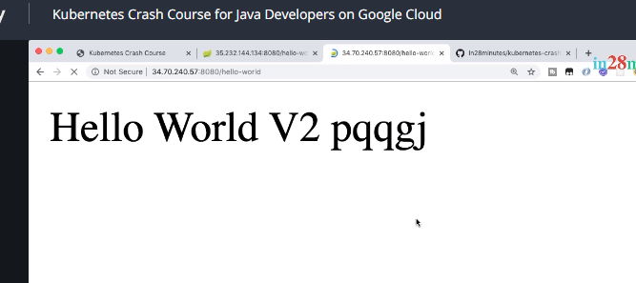

So, and after a few seconds, you'd see that V2 is the only application which is live.

So, we have switched off V1 and we are completely switched on with V2.

Don't really worry. If any of these concepts were new to you, you were not able to understand the terminology, or the commands seemed very complex. The idea was to show you what you can do with Kubernetes and you would see that by the end of this course, you'd be able to do this and actually a lot more with Kubernetes.

Whatever you are seeing until now is the magic that Kubernetes enables. You could see that with just seven or eight simple commands, we enabled powerful features on our application. We made it auto scale based on the load. We were seeing that Kubernetes was automatically doing the load balancing between the available instances. We were also seeing the fact that Kubernetes is monitoring the whole thing and when an instance goes down, it immediately brings another instance up and we were able to easily release a new version of the application with zero downtime and all this with seven or eight instructions. The amazing thing about Kubernetes is the fact that you can scale whatever you are seeing right now to thousands of micro services having thousands of instances in a declarative way. You tell Kubernetes, I need hundred instances of this micro service running and you don't need to do anything, Kubernetes would make sure that it would happen. And on top of this, Kubernetes is cloud-neutral.

There are solutions provided by different cloud providers:

AWS, Azure, Google Cloud. Each one has their own Kubernetes solution and you can install Kubernetes on any of these cloud providers.

So, if you are deploying your applications to Kubernetes, you can run in any of the clouds. You will learn all the magic about Kubernetes during this course with a number of spring micro services.

Now, where do these micro services run? You need a Kubernetes cluster or a group of servers. One of the interesting things about Kubernetes is that setting up Kubernetes is not easy. Creating and managing kubernetes clusters can be really really tough.

And that's where we use GKE, Google Kubernetes Engine.

GKE is a managed service provided by GCP. So, Google Cloud Platform provides this managed service called the Google Kubernetes engine.



So, we don't really need to worry about creating a Kubernetes cluster and maintaining it.

Google takes care of it for us.

And the amazing thing is, we'll be using the same infrastructure that Google uses to run Google Maps, Gmail, YouTube, and Google Search.

Creating Google Cloud Account

Welcome back.

Are you excited to deploy your first application to Kubernetes?

Let's get started. Let me start with reminding that Kubernetes can be tough to get started with. There are a wide range of concepts you'd need to learn to master Kubernetes like clusters, nodes, pods, containers, deployment, service, replica set, and a host of other features.

And also, we are working with Kubernetes on Google Cloud Platform. This throws in a few of the Google cloud concepts as well:

Regions, zones, projects, compute engines.

Some of these terms can be intimidating at first but I promise, by the end of the first one hour of the course, all these would start making perfect sense. Each of the concepts that we talked about are interconnected and you cannot understand one without understanding another.

However, the great thing is that we found a hands-on approach to break this down and make it really easy for you. We really believe that complex things should be explained by breaking them into small understandable chunks and explained in small practical steps.

Our aim for the first section of the course is to deploy a simple REST API to Kubernetes. Now, what do you want to be able to deploy something to Kubernetes on Google Cloud?

The first thing you would need is a Google Cloud free trial account. The second thing is, we'll create the Kubernetes cluster and then we'll be all set to deploy our REST API. As we go through these steps, we will demystify all the important concepts and help you master Kubernetes. In the step, let's get started with creating a Google Cloud free trial account.

Make sure that you're logged into your Google account and go to the website

cloud.google.com.

Creating Kubernetes Cluster with Google Kubernete Engine (GKE)

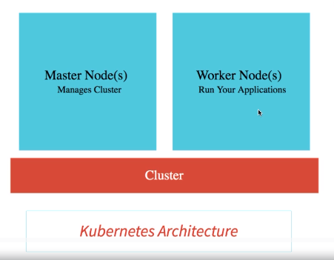

Welcome back.

Are you ready to create your first Kubernetes cluster?

Let's get started. Now, what's a cluster?

Let's take a step back.

The best way I found to describe Kubernetes is that it's the best resource manager ever. What does a resource manager manage? It manages resources.

So, what are the most important resources that Kubernetes manages? It's your servers and these servers are in the cloud.

So, they are virtual servers.

They are not real servers, but they are actually servers which are in the cloud which are typically called virtual servers.

The fact is that different cloud providers have different names for these virtual servers.

Amazon calls them EC2, Elastic Compute Cloud. Azure calls them virtual machines and Google Cloud calls them compute engines.

And what does Kubernetes call them? Kubernetes uses a very generic terminology and calls them nodes.

Kubernetes can actually manage thousands of such nodes. Now, what do we do when you have thousands of things to manage?

You introduce managers. While you might not really like your manager, managers do really have a role to play. To manage thousands of Kubernetes nodes, we have a few master nodes.

Typically, you'll have one master node, but when you need high availability, you go for multiple master nodes.

So, what is a cluster? A cluster is nothing but a combination of nodes and the master node. The nodes that do the work are called worker nodes or simply nodes. The nodes that do the management work are called master nodes. These master nodes ensure that the nodes are really motivated and charged up to do the work, just like our manager does. Isn't it how it works? We work hard because our managers keep us on our toes. I was just kidding. Master nodes ensure that the notes are available and are doing some useful work. So, at a high level, a cluster contains nodes which are managed by a master node. Now that we understood this, let us get down to creating a cluster.

When we created our Google Cloud account, this is the page where we ended up on.

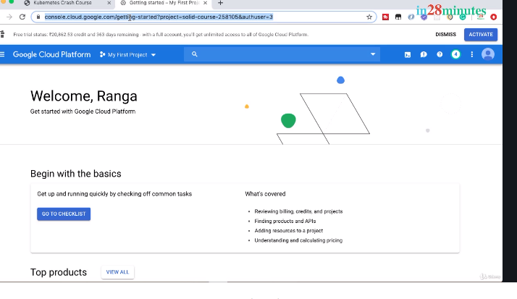

My First Project. By default, this should be already chosen. Make sure that you are inside the My First Project. And what we'd want to now start doing is to enable something called a Kubernetes engine.

How do we do that? The way we can enable a Kubernetes engine is just by saying Kubernetes and clicking the Kubernetes.

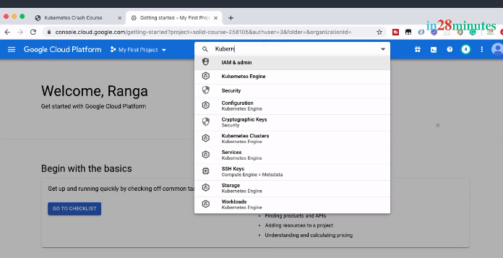

Engine icon which comes up. Once you click the Kubernetes Engine icon, it would take a little while before the Kubernetes Engine is activated. Until a little while, you will see that the create Cluster button is actually disabled and it might take a minute and after that, you would see that the Create cluster button is enabled.

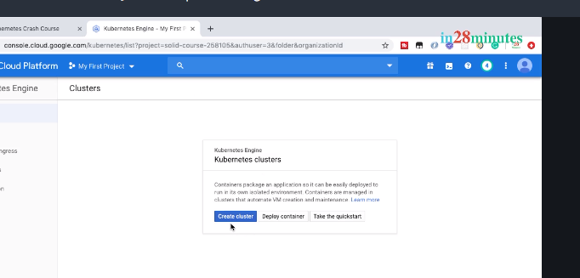

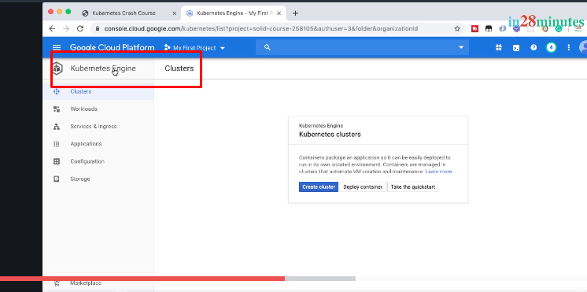

What you are seeing in here is what is typically called the Kubernetes Engine dashboard.

Let's get a quick overview of this dashboard.

You have Clusters where you can create clusters and manage them.

You have Workloads where you can manage the applications or the containers that you would want to deploy into the cluster.

Other than that, you have Services & Ingress. Some of your workloads may actually be REST API or web applications.

You'd want to provide access to external world to these workloads and that's where services come into picture.  Services give external world access to applications which are deployed into Kubernetes clusters.

Other than that, there are a few other things that your workloads need: configuration to store your application configuration, storage to provide persistent data storage for your application.

We'll get to all of this in due course and discuss them in detail. For now,

Let’s get started with creating a cluster.

When you're creating a cluster, you would need to choose how powerful your cluster is and where it should be located.

You will need to choose the type of nodes you want, the number of nodes you want, and their location. You'd see a few new terminologies. Don't worry.

Let's take the defaults and get started.

Let's click Create cluster.

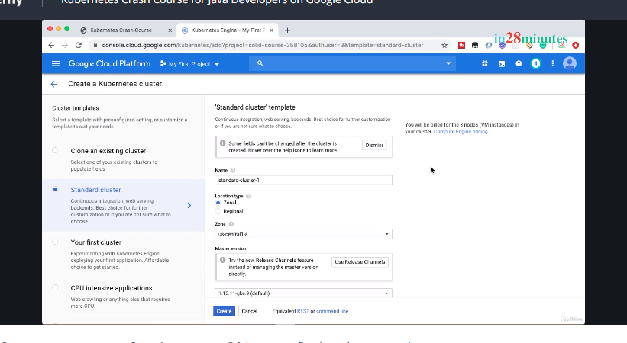

First thing is, make sure that you are inside first project. A project actually makes it very very easy to manage your resources in the cloud. There are a wide variety of resources like virtual servers, cloud databases, Kubernetes clusters and we would want to make sure that all these resources that we are creating, go into the right project. The second thing is, we're using a standard cluster for now.

This standard cluster provides the best configuration for getting started with learning Kubernetes.

There are a lot of other advanced options, we will look at later.

Now, I'll call this cluster as in28minutes- cluster and I'll choose to locate this specific thing in us-central1-a. I would recommend you also to choose us-central1-a because the features offered by Google Cloud sometimes change based on the location.

So, I would recommend you to actually choose us-central1-a as well. The next thing is to choose the Kubernetes version. I would recommend you to choose the default one which is recommended. Next, we would configure our nodes, our virtual servers, where our application will run. We will start with three nodes in our cluster. We will choose General-purpose nodes. Actually, Google Cloud provides a variety of nodes: CPU optimized, memory optimized, GPU optimized for graphics. What we'll do is, we'll stick with the basics and choose the defaults. You'll see that with each of these nodes, we get one virtual CPU and about 3.75 gig of memory. Now, let's go ahead and click Create. This would kick start the creation of a Kubernetes cluster. This would take about five minutes to complete. 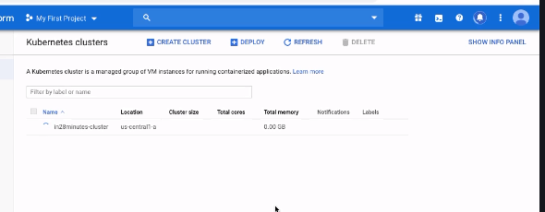

So, let's take a step back and look at what we did in this step. We understood what a cluster is at 10,000 feet.

We talked about the fact that a Kubernetes cluster has a set of nodes which do the work and a set of master nodes which manage the nodes.

After that, we kicked off the creation of a Kubernetes cluster on Google Cloud. Before I take leave, an interesting fact. Creating a Kubernetes cluster is one of the things that system administrators dread. Google Cloud really makes it very very easy to create a cluster. Google Cloud is actually doing a lot of amazing things in the background right now to get a stable cluster for you.

But going back a few years, you cannot imagine how difficult it was to create Kubernetes clusters. I'll see you in the next step where we will start making use of the cluster we are creating.



Review Kubernetes Cluster and Learn Few Fun Facts about Kubernetes

 See a icon saying the cluster is running. On the screen, you can see a little bit of generic information about this cluster. It has three nodes, it has three virtual CPUs, and it has 11.25 GB of memory. We saw that each of

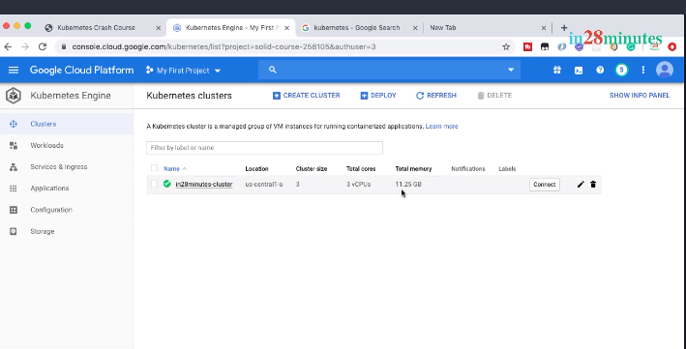

The nodes had three 3.75 GB and 3.75 GB into three is what you see here, 1125 GB.

Now, let's go inside where you can see some more genetic information about the specific cluster.

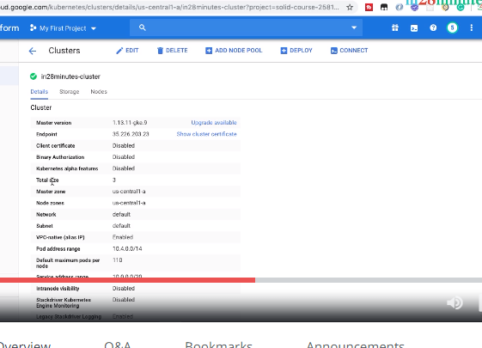

 You can see which version of Kubernetes it is making use of, you can see the total size, you can see the location of where the master node is present, where the worker nodes are present, and a few other details about the cluster.

If you go to the nodes, you can also see the details of all the nodes which are present.

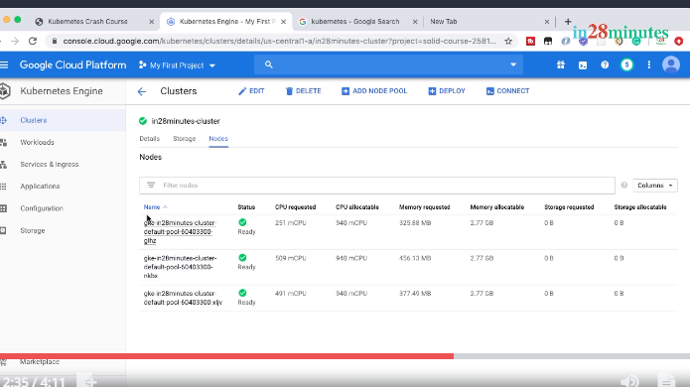

On the screen, you can see more information about the nodes. You can see that there are three nodes; you can see that some amount of CPU has already been requested on these specific nodes. You can see how much CPU is available and also, you can see how much memory is available for new applications on this specific node. Let's talk about something very very important before we move into the next step. When we created the nodes, we created them with one vCPU and about 3.75 GB of memory. However, if you see right now, there is only about 2.75 GB of memory that is available on each of these nodes. What is happening with the rest of the memory? Who is making use of it? The answer is Kubernetes. Kubernetes needs to manage the nodes and like every manager. Kubernetes takes a cut. It says, hey, I need to do a lot of work to manage these nodes. So, reserve some CPU and some memory for the work I need to do with these nodes. In a later step, we will dig deeper into what kind of processes Kubernetes runs on these nodes. But at a high level, it's important to understand that Kubernetes has something installed on each of these nodes to manage them. In this step, we discussed a few fun facts about Kubernetes and saw that our cluster is up and running. Are you excited to deploy your first application to Kubernetes?

Let's start with that in the next step.



Deploy Your First Spring Boot Application to Kubernetes Cluster

Welcome back.

Are you excited to deploy your first application to a Kubernetes cluster? I am excited to get you there. Now, what we need to do to deploy an application to a Kubernetes cluster? The first step is actually to connect to the Kubernetes cluster. How do we connect to the Kubernetes cluster? We are awesome programmers; we will use the command line. Typically, when we want to use command line, we would need to install a lot of software. However, Google Cloud really makes it very very easy. It provides you something called Google Cloud Shell. Now, the first thing is, make sure that you are inside the cluster. So, over here, what I'm doing is, I'm going inside the cluster which we have created earlier and what I'll also do now is to activate cloud shell. So, there's an icon present down here to activate cloud shell.

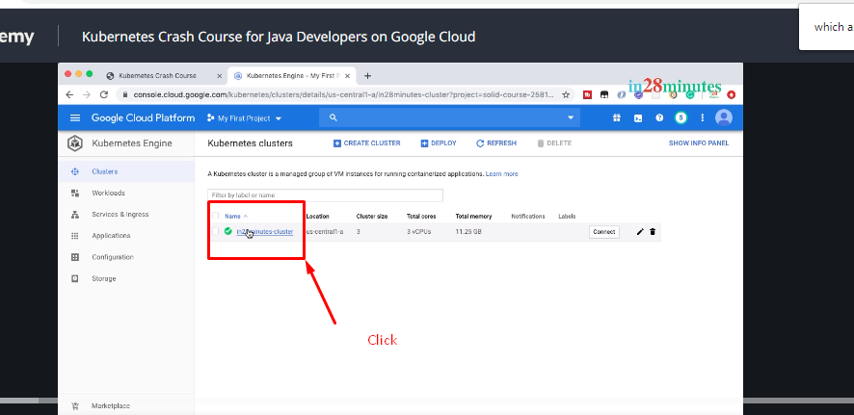

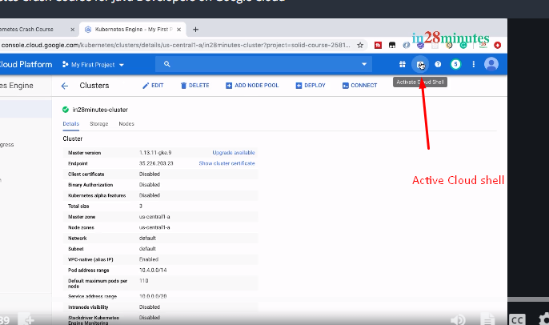

When you click it, you'd see that the cloud shell opens up here.

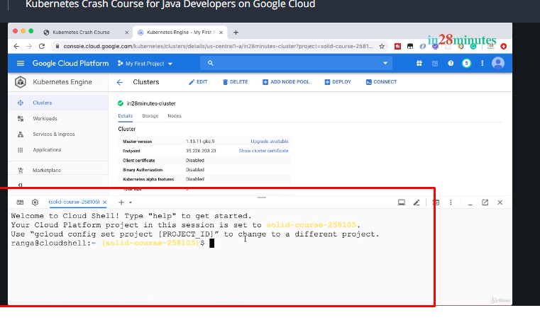

You can click this icon, which is present in here which says, Open in new windows.

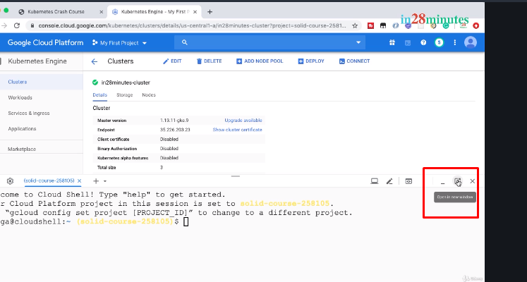

So, this would open up the cloud shell in a new window of its own. Cool!

Now, it's launched up here. So, what I'll do is, I'll close the terminal down here.

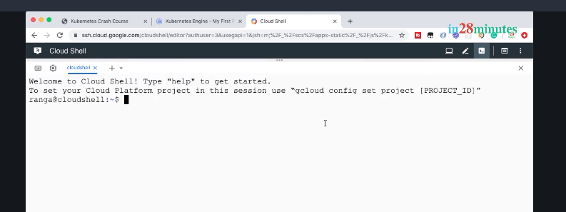

So now we have the Cloud Shell launched up in its own window and we have a complete UI for the cloud platform also available for us in Cloud Console. We'd want to connect to this cluster.

How do we do that?

Click the Connect in here

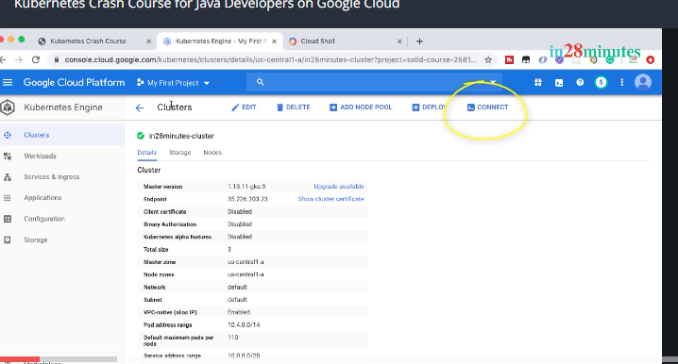

I'll click the icon which is present in here to copy the command to click and I'll run it in here.

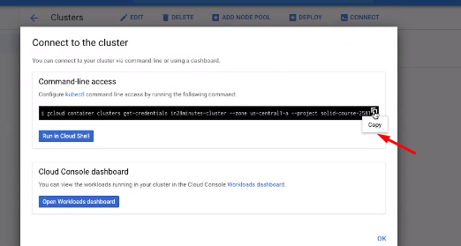

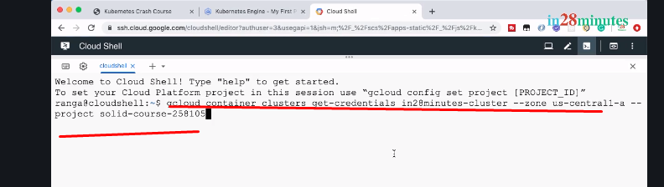

CMD:

gcloud container clusters get-credentials in28minutes-cluster --zone us-central1-a --project solid-course-258105

You'll see that this command is a Google Cloud command to connect to the cluster.

So, we're connecting to the in28minutes cluster that we created earlier. We are connecting to the cluster which is in zone us-central1-a and we're using the project ID for the project that we have.

The project that we are using is My First Project.

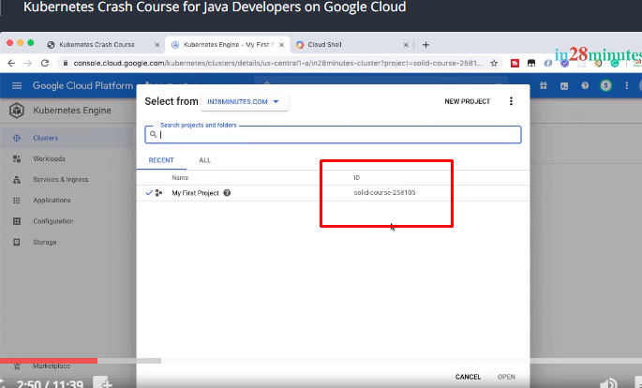

And you can see that the ID for that course is actually solid-course-258105.

So, that's the entire command that we are executing to connect to the cluster.

So now, you can see that we are connected to the cluster.

We would want to run commands against this cluster. How do we do that?

That's where something called Kubectl comes into picture. Kubectl is K-U-B-E-C-T-L. Kubectl is shot form for Kube controller is shot form for Kube controller.

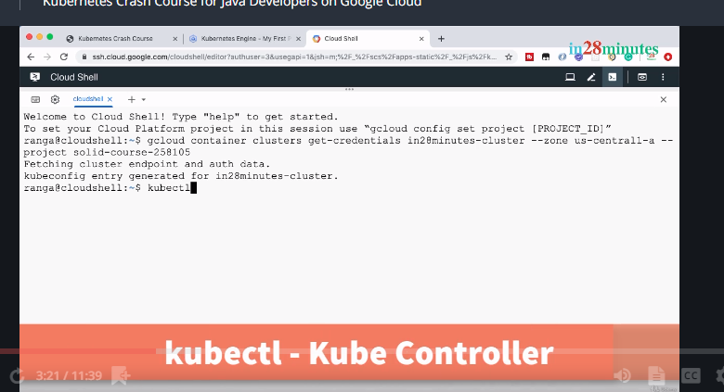

Make sure that you remember this very very well because we would be using tons of times during this course.

Kubectl is an awesome Kubernetes command to interact with the cluster.

The interesting thing is, Kubectl would work with any Kubernetes cluster, irrespective of whether the cluster is in your local machine, whether it's in your datacenter, or it's in the cloud. Once you connect to the cluster, you can execute commands against any cluster using Kubectl. Kubectl can do a lot of powerful things for you with Kubernetes. You want to deploy a new application, Kubectl. You'd want to increase the number of instances of an application, Kubectl. You'd want to deploy a new version of the application, Kubectl.

The awesome thing is Kubectl is already installed for us in the Cloud Shell.

So, let's go ahead and type in kubectl version. Hmm

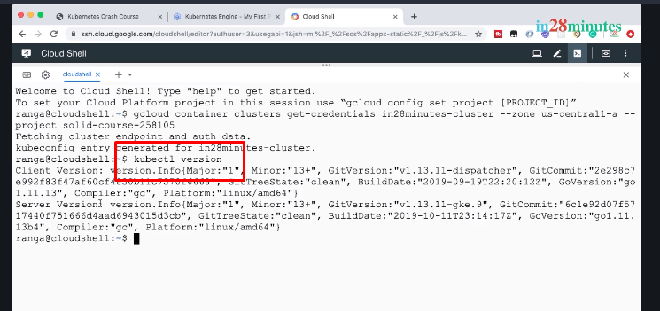

Now we have launched up Cloud Shell, we are connected to the cluster, and we are ready to execute commands against the cluster. We would want to deploy an application.

kubectl create deployment hello-world-rest-api --image=in28min/hello-world-rest-api:0.0.1.RELEASE ---(Step 1)

Hello-world-rest-api 🡪 Application Name

--image=in28min/hello-world-rest-api:0.0.1.RELEASE 🡪 container image

Now, you might be wondering where is this image coming from? You might be wondering what's this in28min/hello-world-rest-api:1.0.0.RELEASE. What does it contain? How was it created? The thing is, this is the Docker image for the REST API that we would want to deploy. If you are familiar with Docker images, you'd know that there are a few steps which are involved in creating Docker images and pushing out to Docker Hub. What we have done is to help you get started quickly, we already created a Docker image for the Hello World REST API and pushed it to the Docker repo which is Docker Hub. If you go to hub.dcker.com/u/in28min and look for in28min/ hello-world-rest-api, you would see that there is a repository which is already present in here and if you go to the tags, you would see that there are a few releases for these applications already present. The one which we are making use of right now is this 0.0.1.RELEASE. We are right now trying to deploy this image. Now, don't really worry about the creation of the image. What we'll do is, for the subsequent applications in the course, we'll create Docker images, deploy them to Docker Hub, and use them from Kubernetes. For now, let's keep our focus on understanding Kubernetes. So, let's keep going.

Now step1 press enter

This would deploy the application to a Kubernetes cluster and it gives you a deployment ID.

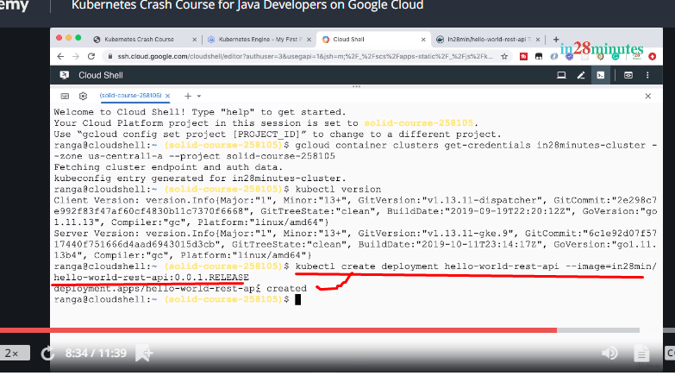

So, it says, this deployment is created.

Now, what do we want to do? We would want to expose this deployment to the outside world.

kubectl expose deployment hello-world-rest-api --type=LoadBalancer --port=8080

Note: we would want to expose it as a load balancer.

This would expose a service to the outside world.

You can see that there is a service which is being exposed right now. Now, we'd want to find out the status of creation of these.

What we'll do is, we will go to the UI and check that up. So, let's say OK in here. Let's go to Service & Ingress. It's taking a little while for the page to load.

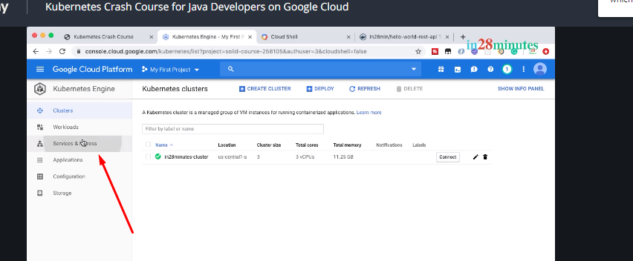

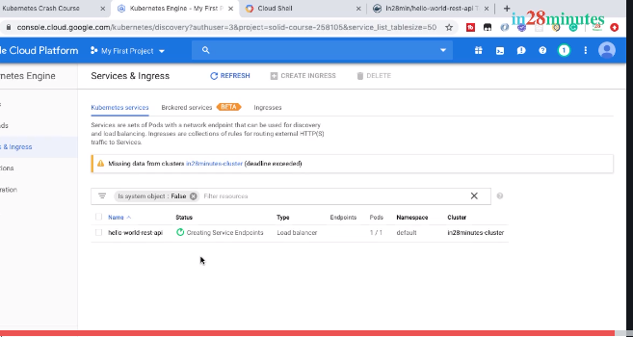

You’d see that it's creating service endpoints.

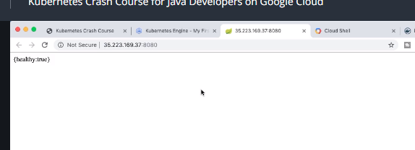

Now it is working fine..............

Quick Look at Kubernetes Concepts - Pods, Replica Sets and Deployment

We have an application running in the Kubernetes cluster. How did the magic happen? What's happening behind the screens? Let me start with a warning. Getting an application up and running in Kubernetes is the easy part. Understanding what's happening in the background really get messy. There are tons of new concepts involved. So, buckle up and let us get on the Kubernetes roller coaster ride right now. You'll see that there are a number of bumps on the way, but that's how things will remain exciting.

Let's get started now.

Let's go to Cloud Shell and execute a command

kubectl get events

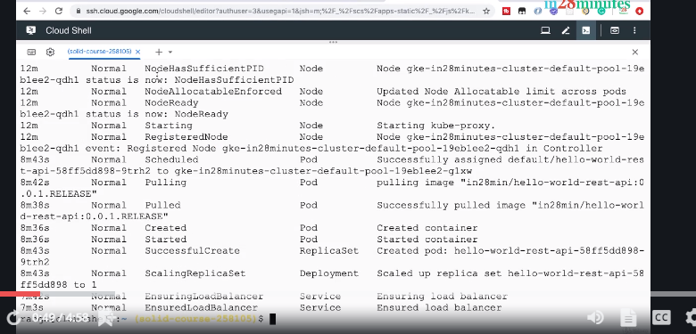

You can see a lot of events have happened. The first events that you are seeing in here are all related to creating the cluster. This is where; this is the event where we started creating our application. You can see that there is a pod which was created, there like there is something called pulling a image which is happening in there, and it does a sequence of steps to start up a container, and after that, you would see something called a Replica Set, you would see something called a deployment, and finally, you see something called a service. We created and exposed a simple deployment and the Kubernetes magically created for us a pod, a replica set, a deployment, a service.

Now, what is a pod?

What is a replica set?

Why are these being created when I create a deployment?

What is a service? Kubernetes really likes to make things very very complex. So complex that is very very difficult to understand.

I was kidding.

Let us now break it down.

Let us run a few more commands.

kubectl get pods

This would get all the pods that were created. So, you can see that there was a pod which was created; it's in a status of running.

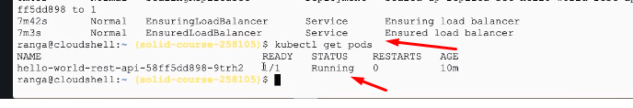

Now, we got the pods. What's the command for getting a replica set?

kubectl get replicaset

What's the command for getting a deployment?

kubectl get deployment

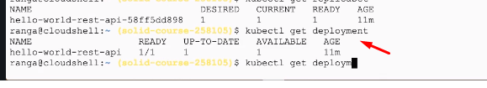

What's the command for getting services?

kubectl get service

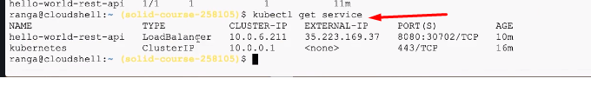

Now, what do these do and why do we have so many concepts?

Each of these concepts has a prominent role to play in Kubernetes being very successful. Each of these concepts have one important responsibility that they do really well and as a combination, they provide the important responsibilities of Kubernetes which are to manage workloads, to provide external access to workloads, to enable scaling, and to enable zero downtime deployments. In this step, we understood the fact that there are a number of important concepts involved in how Kubernetes achieves its goals: Services, pods, replica sets, and deployments. Starting next step, let's dissect each one of these concepts and understand them in depth.

Understanding Pods in Kubernetes

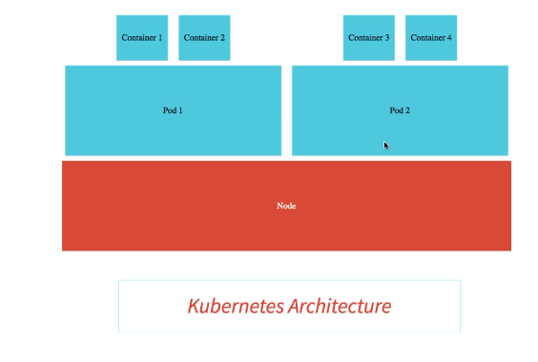

Welcome back.

In this step, let's start with understanding pods. Pods is the most important concept in Kubernetes. A pod is the smallest deployable unit in Kubernetes.

You might think containers are the smallest deployable unit, but no. In Kubernetes, the smallest deployment unit is actually the pod. Let's consider a question. I'd want to create a container in Kubernetes. Can you do it without a pod? The answer is no. You cannot have a container in Kubernetes without a pod. Your container lives inside a pod. Now, what does a pod have and why do we need a pod?

Let us look at it in this specific step.

kubectl get pods -o wide

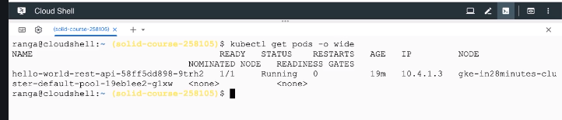

Now, what are the details that you are seeing in here?

One of the important things that you're seeing in here is the IP address of a pod. Each pod has a unique IP address.

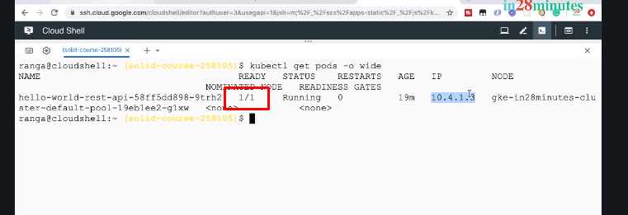

The other thing which you are seeing in here is the one by one, which is the number of containers that are present in that specific pod and how many of them are ready.

A pod can actually contain multiple containers. All the containers which are present in a pod share resources. Within the same pod, the containers can talk to each other using localhost.

 Now, let's do another command.

kubectl explain pods

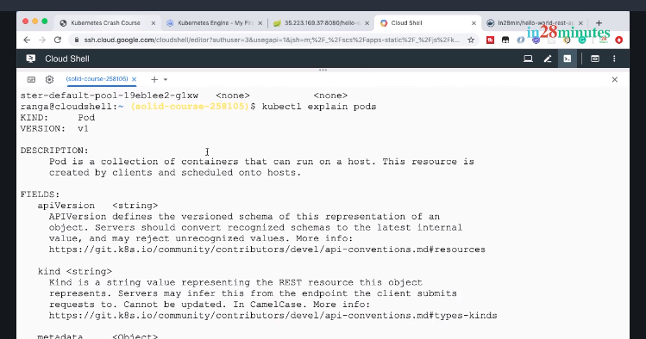

So, what does kubectl explain pods bring us?

It says what a pod is. A pod, in Kubernetes, is a collection of containers. So, a pod can contain multiple containers that can run on a host that can run on a single node. This resource is created by clients and scheduled on to hosts.

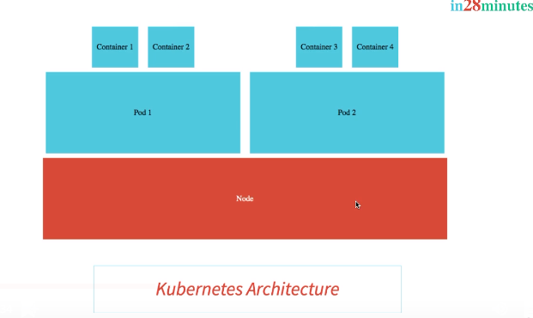

So, what we understand is the fact that a Kubernetes node can contain multiple pods and each of these pods can contain multiple containers. These pods can be from different applications or these pods can be related to the same application. Now, let's go back to the Cloud Shell and execute another command.

What we want to do is to get the details of the pod.

So,

kubectl get pods

We did kubectl get pods to see high-level details of this specific pod.

I would want to see this in depth. How can I do that? One of the ways is actually now I'll copy the ID of this pod.

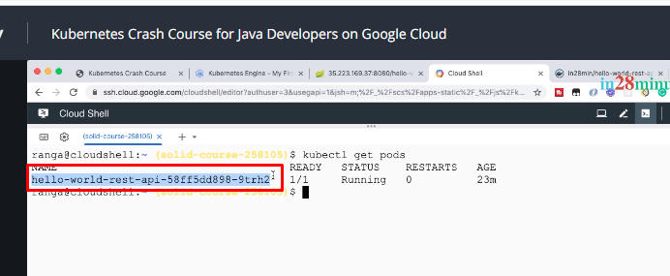

kubectl describe pod hello-world-rest-api-58ff5dd898-9trh2

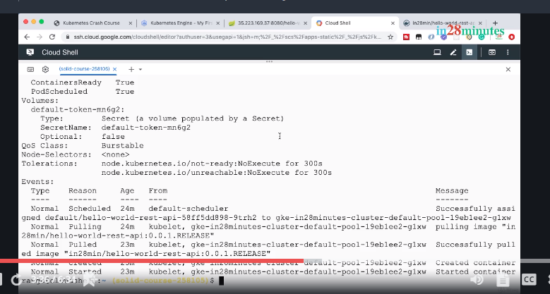

What would happen now? You can see that it brings in a lot of details about that specific pod. You can see the name of the pod. You can see that the pod has the IP address 10 4.1.3. You can see that the pod is actually running on a specific node, the details of which you can find in here. You can also see that the pod is running in a default namespace. Namespace is a very important concept. It provides isolations for parts of the cluster from other parts of the cluster. What do I mean? Let's say, you have your development and QA environments running inside the same cluster. How do you separate the resources of dev from the resources of QA? One of the options is to create separate namespace for QA and Dev and associate each of the resources with that specific namespace. For now, let's keep things simple and stick to the default namespace.

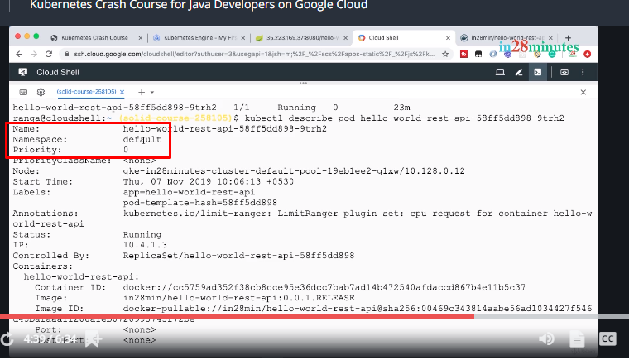

Now, what else does a pod have? You can see that the pod has labels. We are attaching a label called app=hello-world-rest-api with this specific pod. Earlier, we talked about a number of concepts: a pod, a replica set, a deployment, a service. In Kubernetes, the way you link all these together is by using something called selectors and labels. So, labels are really really important.

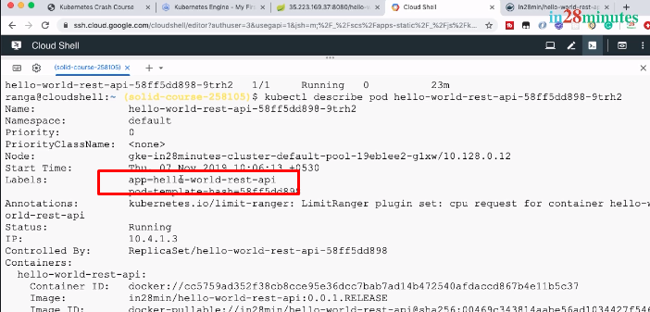 When we get to tying up a pod with a replica set or a service, we'll talk about it in further depth. Now, the other things that are associated with the pod are annotations. Annotations are typically meta information about that specific pod. What was the release id, what was the build id, what was the author name, and all that kinds of stuff are what are put into annotations. And the last thing that you'll see in here is something called a status. This pod is currently in a running status. The important thing that you need to remember about pod is, a pod provides a way to put your containers together.

It gives them an IP address and also, it provides a categorization for all these containers by associating them with labels. At a high-level, this is how you can picturize how pods would be running on nodes.

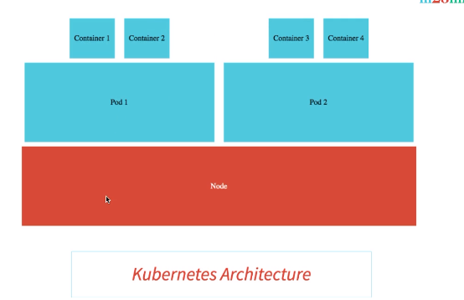

On any Kubernetes nodes, there can be multiple pods and each of these pods can contain multiple containers that are running as part of them. I hope you are having an interesting time and I'll see you in the next day. Until then, bye-bye.

Understanding Replica Sets in Kubernetes

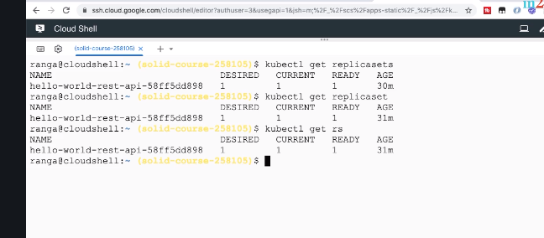

Welcome back.

In this step, let's get started with ReplicaSets.

If I do a kubectl get replicasets, I would get the replicaset which was created for us earlier.

You can also get the replicasets details by just typing in kubectl get replicaset

Instead of using a plural,

you can also use singular replicaset or if you're lazy like me, you can even use a shortcut.

You can say, kubectl kubectl get rs and it gives you the details of the replicaset.

Now, the question is, why do we need a replicaset. What is the role that they play? Replicasets ensure that a specific number of pods are running at all times.

Over here, you can see that the desired number of pods that we want running is 1 and currently, there is one container in the ready status.

What I'll do is, I'll say

kubectl get pods -o wide

As we used in the earlier steps, -o wide will add a few more details to the get pods and shows a little bit more information. It shows the node where it is running, it shows the IP address, and things like that.

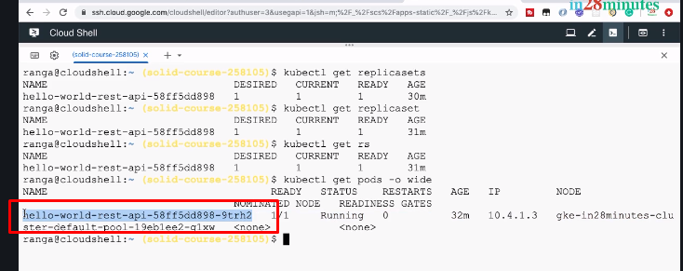

You can see that right now, there is one pod. Carefully notice this specific id. What we would want to do is, we would want to actually kill this pod. So, let's take this id.

kubectl delete pod hello-world-rest-api-67c79fd44f-n6c7l

The pod is deleted. Now,

kubectl get pods -o wide

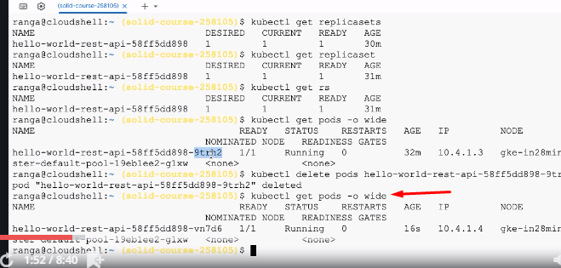

What would happen? You can see that this pod is no longer present because we have deleted it. However, you can see that there is another pod which is started up: vn7d6.

That pod is automatically launched up and it is running.

If you give it a little bit of time, like if you give it about a minute for the application to completely start up, you would see that the URL also continues to run. So, even though we killed a pod, within a minute or so, our URL continues to work.

How is that happening? That's because of the replicaset. The replicaset always keeps monitoring the pods and if there are lesser number of pods than what is needed, then it creates the pods. We said we would want one pod running all the time and when it goes down to zero, immediately the replicaset looks at and says, OK. There is one pod missing, I'll need to start it up and it kicks off a new pod. Now, it's interesting when there is one pod running and we kill it, we saw that the pod is automatically launched up. Now, let's say, in a replicaset I would want to have three pods or two pods.

How can I do that?

How can I tell the replicaset to maintain a higher number of pods? The way we can do that in Kubernetes

kubectl scale deployment hello-world-rest-api --replicas=3

Let's see what would happen. It says the deployment is scaled

kubectl get pods

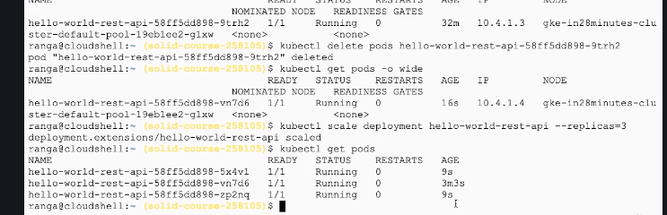

Let's do a simple get pods. Ahaa!

You can see that there are two more pods added in. Who's doing this work?

This work is being done by replicaset.

You can see that right now, there are two new pods.

You can see the age of them. Nine seconds.

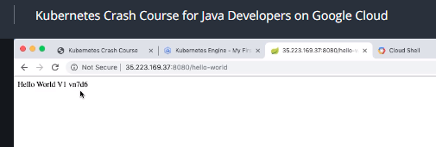

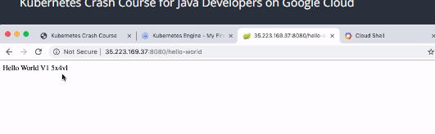

So, you'd see that V1 vn7d6 vn7d6. Cool! Not you'd see a new id coming up, 5x4vl and if you keep refreshing it, you would see that there would be two or three different ids that you'd keep getting responses from. So, what we now have is more than two instances of the application running and they are also having load distribution between them. Let's not worry about the load distribution part for now.

Now let's do a

kubectl get replicaset

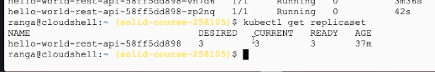

what happened internally is that the replicaset got updated to a desired of three and what it does is, it sees the current plus one at that particular point in time, it says, okay, I would want actually three. So, it launches up three instances. So, that's how three instances are now up and running.

Now, we want to see what's happening in the background.

kubectl get events

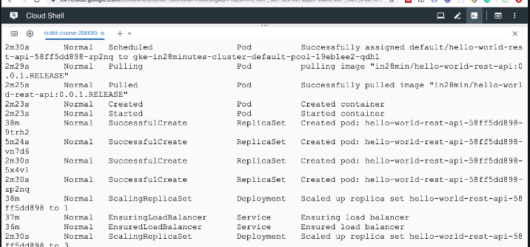

So, when I go to kubectl get events, you can review some of the latest events which happen. One of the interesting things is, this is not in a sorted order. You can see 38 minutes, 2 minutes 23 seconds, 5 minute 24 seconds, and that's not cool.

kubectl get events --sort.by=.metadata.creationTimestamp

You'd want to see actually the events in at least a little bit of a sorted order and that's where we can add an option called sort.by.

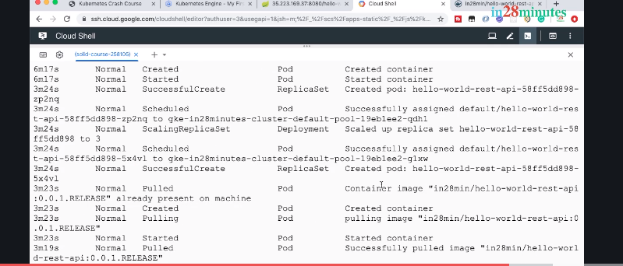

So, you can see that this is where we kill the pod first and when we kill the pod, as soon as we killed it, you can see that a replicaset has started creating a new pod.

Now, after a little while, what we did is, we scaled up the number of instances to three.

Now, after a little while, what we did is, we scaled up the number of instances to three.

How did we do it? We used the scale deployment command and what did the deployment do? It scaled up the replicaset to three. So, when we executed the command, it said, OK, we would want three instances running, so let's scale the replicaset to three. And what does the replica set do? It would start creating new pods. You would see that all the events are happening in here.

kubectl explain replicaset

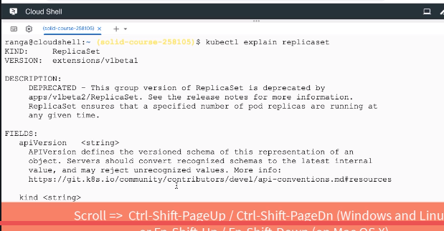

That is their duty. When we scale a deployment, what happens? The deployment updates the replicaset and says, OK, I want three instances. And what does the replicaset do? It checks the current number of pods and if the number of pods is less than what is needed, it would automatically start scaling up. So, in Kubernetes, whenever somebody talks about replicaset to you, it's all about maintaining the number of pods. So, a pod is where your containers run. A pod provides a grouping for the containers and a replicaset ensures that a set of pods, a specified number of pods are always running. In the step, we talked about Replicaset. I'll see you in the next step.

Understanding Deployment in Kubernetes

Welcome back. In the last steps, we understood the need for pods, we understood the need for replicasets. And now, let us try to understand why do we need a deployment. Now, let's say, I have a specific version of application deployed. Let's call it V1. And let's say, we would want to update to a new version, let's say, V2. Typically, what do we want when we are updating applications? We would want zero downtime. Now, let's check the current status right now.

kubectl get rs

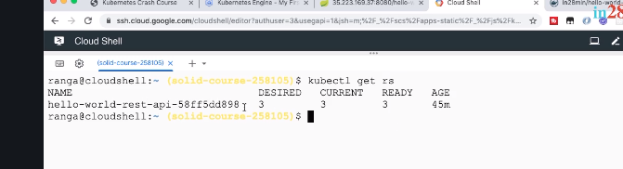

Now, we have hello-world-rest-api with a desired of three and ready is three. That's cool.

And I'll say

kubectl get rs -o wide

So, you can see now the details of the images that are associated with the replicaset as well.

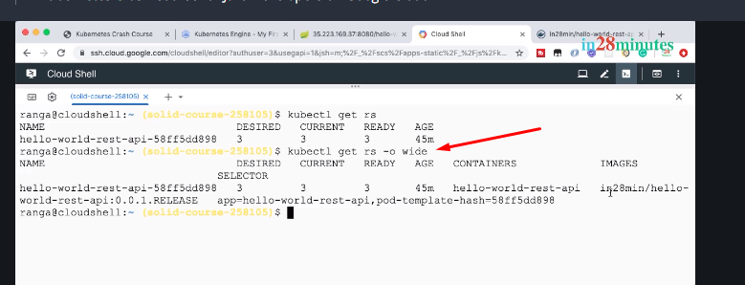

You can see that currently, this replicaset is tied to a image, in28min/hello-world-rest-api:0.1 0.1.RELEASE.

Now, I would want to deploy a new version of this hello-world-rest-api. How can I do that? The command to be able to do that

kubectl set image deployment hello-world-rest-api hello-world-rest-api=DUMMY_IMAGE:TEST

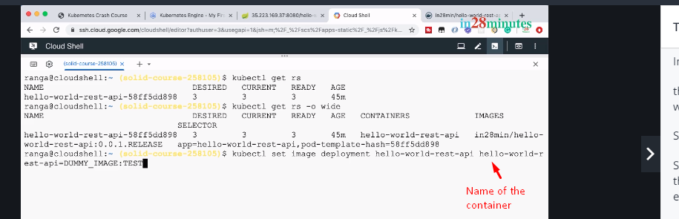

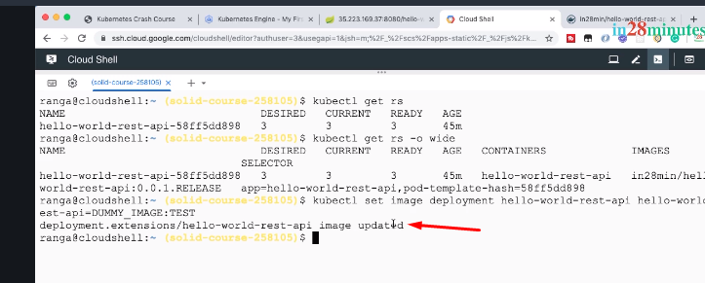

Now, let's see what would happen now. Let's press Enter. Cool! It says, hello-world-rest-api image is updated. Okay. But the error, like the image has an error, right. So, does our application go down?

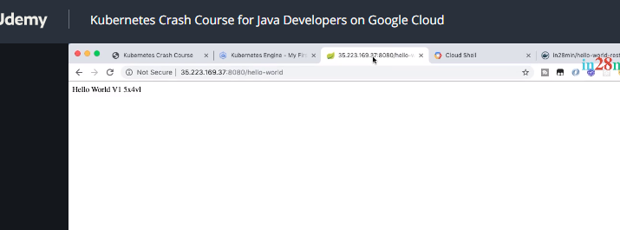

Let's go and run the URL. Hmmm. You can see that the application is still running and you'd be, like if you keep running it, you'd see that you'll get requests from all the current instances. That's cool. So, even though we made a mistake with our deployment, we see that the application is still up and running. The old version is still running. That's cool, right. Now, let's see what's happening in the background.

kubectl get rs -o wide

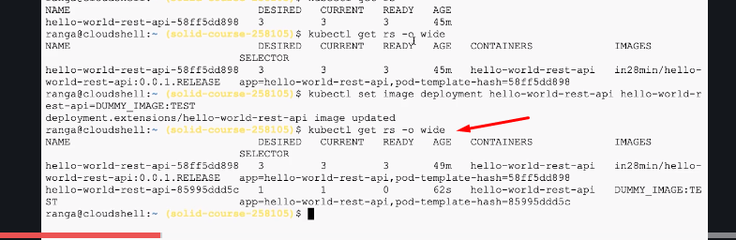

What you're seeing here is two replica sets. So, there's one replicaset which is associated with hello-world-rest-api:0.0.1.RELEASE, which is having three instances running right now and you can see the age of it, right. It's 49 minutes, it's running from long time and there is a second replicaset which has been created recently, about 60 seconds back, and you can see that the image which is associated with it is this and what's happening with it? You can see that the desired status for it is one. However, currently, there is just zero in ready. So, none of the containers are in ready state. Why are they not in ready state? Because the image has an error, the image path that we have created has an error.

kubectl get pods

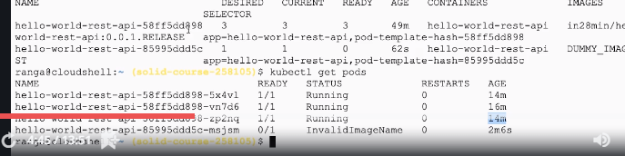

What will happen? You'd see that there are three pods. All these pods have age greater than 14 minutes, which means these are running for a long time. So, these are the ones which are associated with this replicaset, the old one.

The new one which is created, this is the one which is created; this has an invalid image name as the status. So, what Kubernetes has discovered is that the image name which is associated with this specific pod is not really right. And that's why the status for it is InvalidImageName. If you are interested in the details of it, I can actually copy the id of the pod

kubectl describe pod hello-world-rest-api-58ff5dd898-9trh2

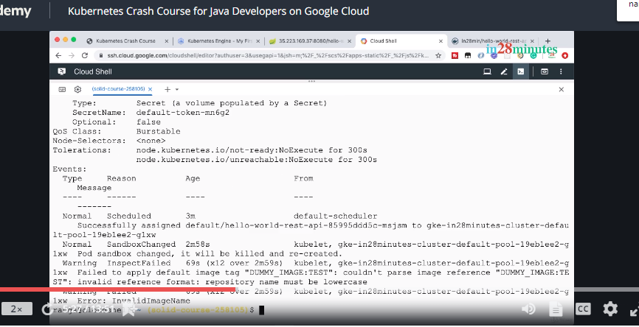

The interesting thing is the last step. You can see that I cannot parse the image reference DUMMY_IMAGE: TEST. It's invalid reference format.

It says, the repository should be in lower case.

kubectl get events --sort-by=.metadata.creationTimestamp

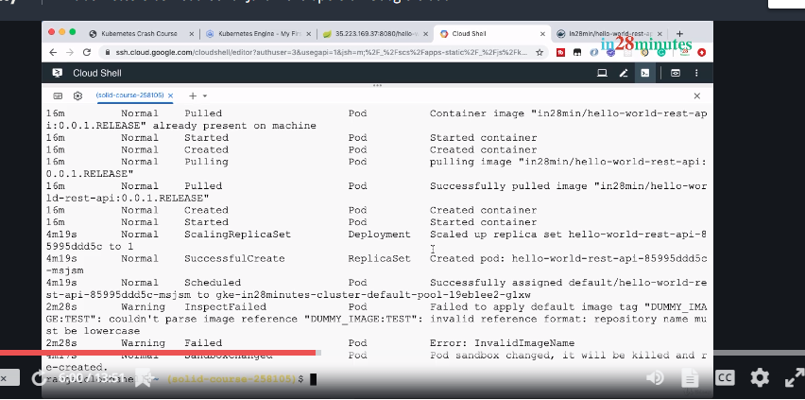

What do we see? We see the sequence of events which are happening.

So, four minutes back was when we started the new deployment and you can see that the deployment has created a new replicaset.

So, a new replicaset was created by the deployment and it said, I need one instance at the start. And what does replicaset do? Replicaset creates the pod.

So, replicaset says, OK we need one pod running at this particular point in time. So, let's create a pod. And what you're seeing is the pod failed to start up.

Let's look at a picture and try and understand what's happening.

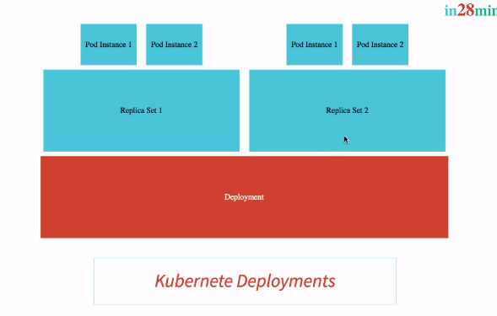

We had a deployment with a Replica Set 1 with three instances. Over here in the picture, we have two instances but in our example, we had three pod instances which are running which were tied to that replicaset and this replicaset was associated with V1 of our application.

And now, when we're trying to do a V2 of the application, what happened? We said, OK create a new deployment. And what did the deployment do? It created a new replicaset. So, it created a replicaset V2 and what it's trying to do is, it trying to launch up pods for that specific replicaset. To start off, what the deployment said is, hey Replica Set 2, start with one instance and the Replica Set 2 is now trying to start up one instance of the pod and right now, it's in a failed status. That's where we are.

let's go back to the Cloud Shell and let's try and update the pod to use a proper image.

So, let's do a set image deployment hello-world-rest-api hello-world-rest-api is equal to, instead of saying, in28min dummy and all that stuff, I would actually give it a proper image name. I'll say, in28min/hello-world-rest-api:0.0.2.RELEASE.

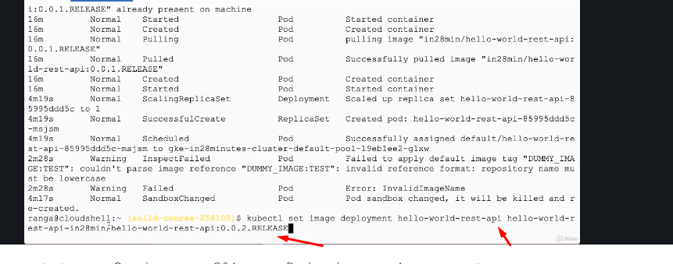

So, let us press Enter right now. You can see that the deployment.extensions hello-world-rest-api image is updated and what would happen?

This is a successful deployment, right.

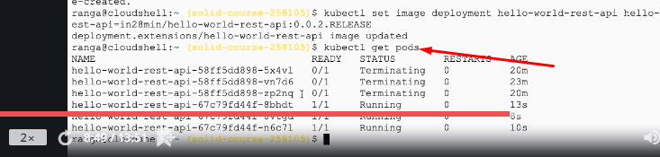

So, let's say, get pods. You can see that there are a few pods in terminating status, three pods in terminating status and there are three pods in running status and all the ones which are in running status are the new ones.

And if I do get replicaset

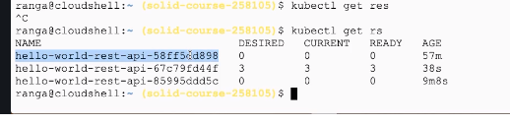

This is the replicaset which we created at the start of the course with V1. This is the replicaset which had an error mage associated with it and now, you can see that there is a new replica set where we have three desired instances and three instances are ready. If you give it about a minute or so and if you start running the application, you'd see that everything is now being distributed to the V2 of the application. So, the V2 of the application is now up and running.

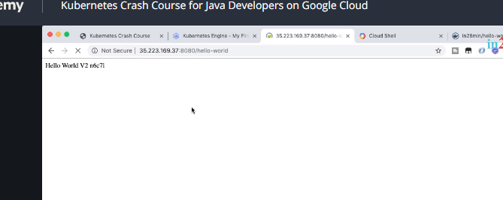

Now, we'd want to understand what's happening in the background.

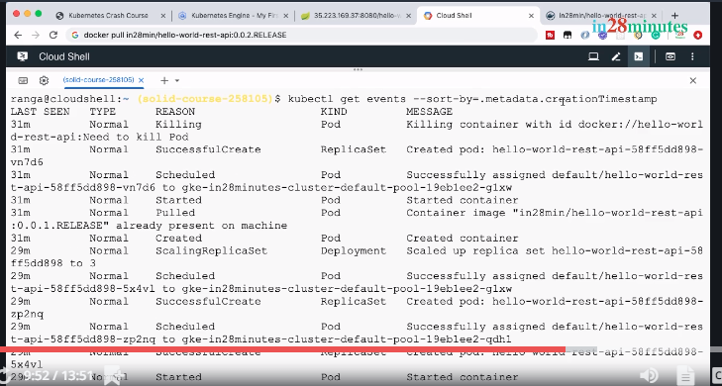

So, as soon as we said, okay release the new version V2, what does the deployment do? It creates a replicaset. It creates a new version of the replicaset for V2 and it says, have one instance. So, this 44f is the V2 of replicaset. So, what does the replicaset do? The replicaset would immediately try to create a pod. If you go further down a little while down, over here, you can see that the pod is created and what happens as soon as the pod is created? The deployment now says, okay, I have one instance of V2 up and running. I don't need three instances of V1 anymore. What it does is, it scales down the V1 replicaset. The V1 replicaset is now scaled down to two instances and it scales up the V2 replicaset to two instances. So, what the deployment is telling is, OK I would want only two instances of V1 running and two instances of V2 running. So, what does the V2 replicaset do? The V2 replicaset creates a pod. What does the V1 replicaset do? The V1 replicaset deletes a pod belonging to V1. Now, after a little while, if you go further down, you'd see that the new pod is created. And what does the deployment do?

Okay, I have two successful pods for V2 and I have two pods with V1.

What does it do? It says, okay now, it's time to increase the number of V2 instances to three and decrease the number of V1 instances to one and that's what it does by updating the replica sets. So, it says, V1 replicaset have one instance, I'm scaling you down and then it says, V2 replicaset, you have more instances, I am scaling you up. So, go to three instances and the pods are created for the V2 instance. And what happens at the end is the V1 replicaset gets scaled down to zero instances and it removes the last pod which was active belonging to V1. Isn't this an interesting journey? I mean, I'll really love the amount of feedback that Kubernetes provides through all the commands that are present and that's the reason why we are focusing on actually executing a lot of commands and trying to understand what's happening in the background. Next time you have a problem with any of these concepts, you can just run these commands and try and find out what's happening in the background and try and make sure that you understand it perfectly. So, in summary, a deployment is very very important to make sure that you are able to update new releases of applications without downtime. The strategy which the deployment is using, by default, is something called rolling updates. What it does is, let's say, I have five instances of V1 and I want to update to V2, the rolling update strategy, it updates one pod at a time. So, it launches a new pod for V2. Once it's up and running, it reduces the number of pods for V1. Next, it increases the number of pods for V2 and so on and so forth, until the number of pods for V1 becomes zero and all the traffic goes then to V2. There are other deployment strategies that we will talk about a little later. I hope you are having an interesting time and I'll see you in the next step. Until then, bye-bye.

Quick Review of Kubernetes Concepts - Pods, Replica Sets & Deployment

Welcome back.

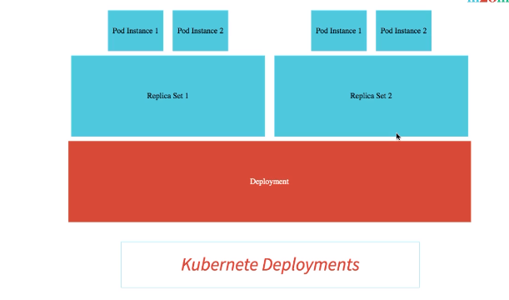

In the last few steps, we executed a lot of commands and tried to dig deeper into pods, replica sets, and deployments. In this step, let us try and summarize what we have learnt in the last few steps. A pod is nothing but a wrapper for a set of containers. A pod has an IP address and it has things like labels, annotations, and stuff like that. Now, why do we need a replicaset? A replicaset ensures that a specific number of pods are always running. So, if you say, replicaset three instances, then it ensures that three instances of the pods are always running. Even if you kill one of the instances of the pod, replicaset would observe that and it would bring up a new instance of the pod. In practice, you'd see that a replicaset is always tied with a specific release version. So, you'll have a replicaset V1 and that would be maintaining a specified number of instances of the V1 release. So, a replicaset V1 is responsible for making sure that that specified number of instances of version one of the application are always running. Why do we need a deployment? A deployment ensures that a release upgrade, a switch from V1 to V2 happens without a hitch. You don't really want to have downtimes when you released new versions of applications and that's where deployment plays a key role. There are a variety of deployment strategies. When I'm releasing a new version of the application, I might want to actually send 50 percent of traffic to V1 and 50 percent of traffic to V2 or I would want to actually do something like a rolling update where I'd want to first create one instance of V2, test it, once it's fine, I would reduce the number of instances of V1. After that, I'll create a new instance of V2. Once it's up and running, I'll reduce the number of instances of V1 and so on and so forth until the number of instances of V1 gets reduced to zero. The default deployment strategy is rolling updates and that's what we saw in action in the previous step. We will discuss deployments in depth when we talk about different release strategies in our future section. Think back and see what we are doing.

We executed a few commands to launch up a few deployments and we executed a tons of other commands to understand what's happening in the background with Kubernetes. That's Kubernetes in a summary for you. Some of the concepts related to Kubernetes might be really really complex to understand.

But as with any good tool, as you understand these concepts, once you master these concepts, Kubernetes will be a dream to work with and that's the reason why Kubernetes is so popular. And that's the reason why Kubernetes is supported by several cloud platforms, almost every cloud platform I should say, and adopted by almost every enterprise across the world. There is one more important Kubernetes concept that we need to understand, that's a service and we'll look at that in the next step. Until then, bye-bye.

Understanding Services in Kubernetes

Welcome back.

In this step, let's try and understand the need for a service.

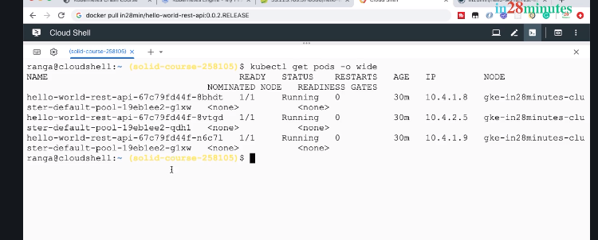

 You can see that each of these pods have their own IP addresses:

and the URL that we are executing on the other hand, if you look at it, it's automatically distributing load among all these pods.

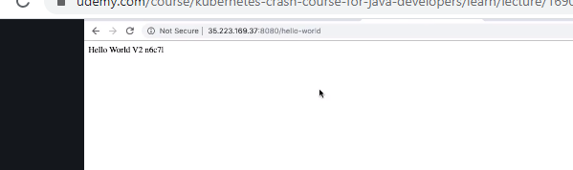

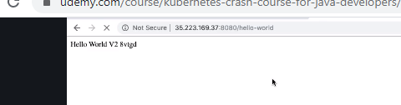

So, if I keep refreshing it, after a little while, you'd see that there are responses coming back from other servers as well.

Now, let's kill one of these pods. What I'll do is, copy this

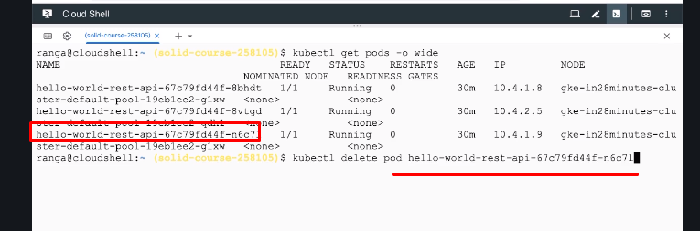

The kubectl delete can be used to delete any of the Kubernetes resources: a pod, a replicaset, a deployment, and we are saying, we'd want to delete a pod and pass in the id of the pod in here.

The pod is deleted.

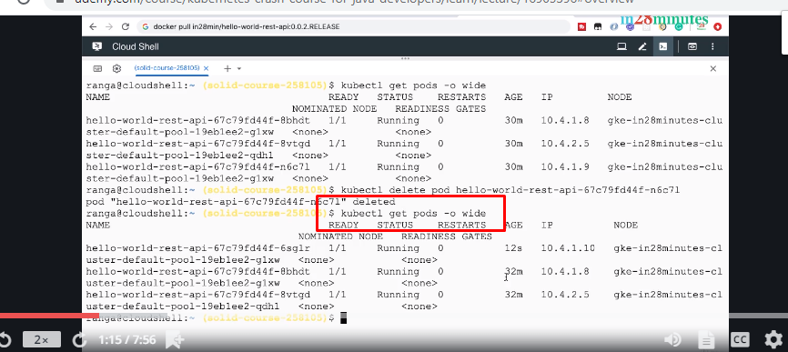

It takes a little while and now you would see if I do a get pods -o wide, you would see that there is a new pod which is started up.

You can see that the age of this pod is 12 seconds. So, you can see that this pod has a new id and the most important thing is, this pod also has a new IP address. So, the IP does of old pod which was deleted is 10.4.1.9 and the IP address of new pod is 10.4.1.10. If I delete another pod. Let's pick up another pod from the list and delete it. Let's pick up one of the older pods. So, let's use this and delete this and get pods -o wide, you'd see that the new port is now getting active. So, 10.4.1.11, 10 seconds, actually 4 seconds. That's the one which is starting up. It's in the running state right now. So, the older pod which we deleted. 10.4.1.8, is no longer active. You can see that each of these pods, whenever it starts up newly, it gets a new IP address. Now, think about your consumers. Do you want to keep giving them new IP addresses?

Nope, right? You'd want to give them one URL and irrespective of the pods in the background, you would want that URL to work. If you look at this specific thing, it continues to work.

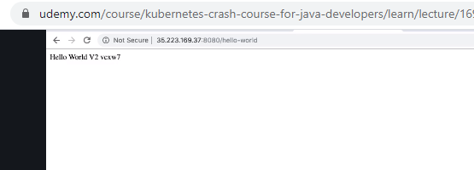

So, if you executed it while the pods are being launched up, while the pods are being deleted, and new ones are being launched up, you would see that this service is always up and running. How is this magic happening? This magic is happening because of something called a service. In the Kubernetes world, a pod is a throw-away unit. Your pods might go down, new pods might come up whenever I do a new release. There might be several new pods which are created and the old pods completely go away. Irrespective of all the changes happening with the pods, we don't want the consumer side of things to get affected. We don't want the user of the application to use a different URL. That's the role of a service. The role of a service is to provide an always available external interface to the applications which are running inside the pods. A service basically allows your application to receive traffic through a permanent lifetime IP address. Now, when was the service created? The service was created when we did an expose deployment. Earlier in the course, we executed kubectl expose deployment hello-world-rest-api --type= LoadBalancer --port=8080.

This is when the service was created with an IP address and that is the IP address that we are using to access the application. Now, let's go to the UI and let's go to the Service & Ingress.

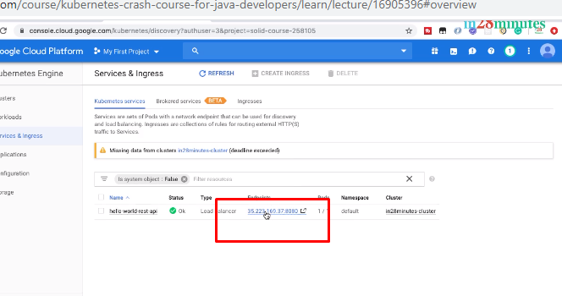

This is the service that we have created, hello-world-rest-api. Status is OK. Type is load balancer and it's load balancing between whatever pods are active at that particular point in time. You'll see the endpoints in here. If you click this and go in and further scroll down, you can see all the labels associated with it, you can see the deployments which are associated with it,

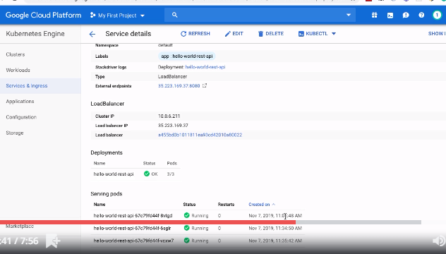

hello-world-rest-api and the pods which are running right now. You can see that these are all the pods which are serving the requests for that specific service. Now, how is this specific service implemented in Google Cloud? There is a Google Cloud load balancer which is created. So, if you search for load balancing

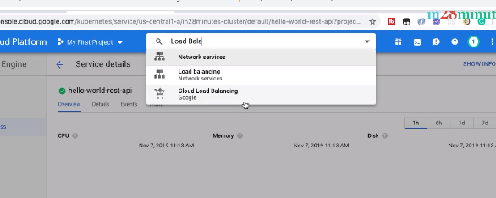 And go to the network services load balancing, you'd see that there is a specific load balancer which was created for this service.

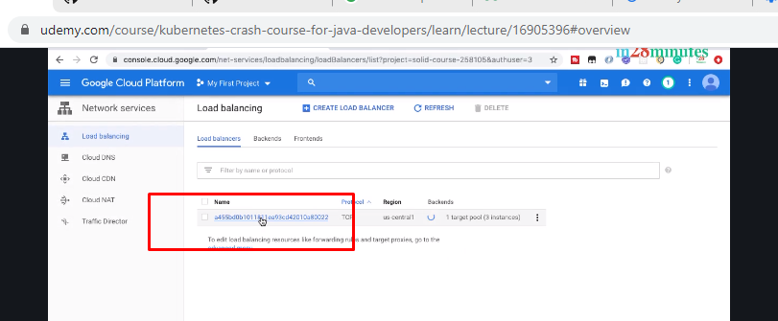

So, let's click that and you can see what are the things that are in the frontend. So, this is the URL that we we are making use of: 35.223.169.37.

You can see that this is the same URL that we are executing in here.

So, that's the frontend and in the backend, we have a number of things. So, this is the load balancer which is getting updated as we create new pods, which delete pods, everything gets updated as the backend. However, the frontend remains the same. The same URL, same port, you will be able to access the application irrespective of how many pods are running in the background. In summary, a service allows your application to receive traffic through a permanent lifetime address. A service remains up and running. It provides a constant frontend interface, irrespective of whatever changes are happening to the backend, which are all the pods where your applications are running. The great thing about Kubernetes is the fact that it provides excellent integration with different cloud providers specific load balancers. We were using a specific type of service called load balancer and we saw that a Google Cloud Platform load balancer was created for us. That shows how well Kubernetes is integrated with Google Cloud Platform to create a load balancer. If you were working with AWS or if you were working with Azure, then that cloud provider-specific load balancers would have been created for you as a service. Let's go to our Cloud Shell, do a clear, and run kubectl get services.

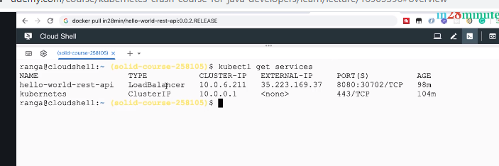

This would list all the services that are running right now.

You see that we have a service, load balancer type of service, hello-world-rest-api that we are working with right now. A load balancer can load balance between multiple pods.

Now, the other type of service is a cluster IP service. Over here you can see that the Kubernetes service is actually running as a cluster IP service. Now, what does a cluster IP service mean? A cluster IP service can only be accessed from inside the cluster. You'd have to be able to access the service from outside the cluster. You can see that there is no external IP for this specific service. So, if you have any services which are directly consumed inside your cluster, you can have them use a cluster IP. I hope you're having an interesting time and I'll see you in the next step. Until then, bye-bye.

Quick Review of GKE on Google Cloud Console

Check in video

**Quick Review of GKE on Google Cloud Console**

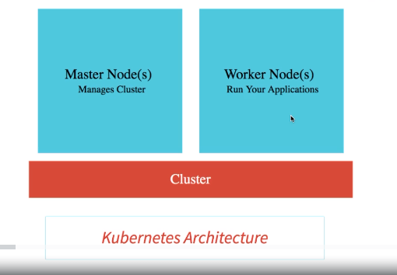

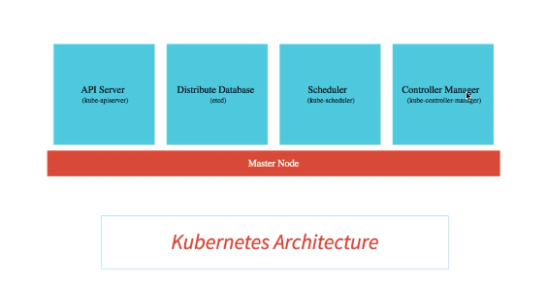

Welcome back. What are the important part of the master node, what are the important components of the worker nodes. Let us look at that in this specific step.

Let's start with the Master Node. What are the important components that are running as part of your Master Node? The most important component that is running as part of your master node is something called etcd. That's the distributed database, etcd. All the configuration changes that we are making, all the deployments that we are creating, all the scaling operations that we are performing, all the details of those are stored in a distributed database. What we are doing when we are executing those commands is, setting the desired state for Kubernetes. We are telling Kubernetes, I would want five instances of application A, I would want 10 instances of Application B. That is what is called desired state and the desired state is stored in the distributed database, etcd. So, all the Kubernetes resources like deployment, services, all the configuration that we make is stored finally into this distributed database. The great thing about this database is that it is distributed. Typically, we would recommend you to have about three to five replicas of this database so that the Kubernetes cluster state is not lost. The second important component inside the master node is something called the API server, kube-apiserver. Earlier, we were executing commands from kubectl, we were making changes from the Google Cloud Console from the interface provided by Google Cloud. How does kubectl talk to Kubernetes cluster? How does the Google Cloud interface or the Google Cloud Control talk to the Kubernetes cluster? The way they make their changes is through the API server. If I try to make a change through kubectl or if I try to make a change to the Google Cloud Console, the change is submitted to this API server and processed from here.

The other two important components which are present in here are the scheduler and the controller manager.

The scheduler is responsible for scheduling the pods on to the nodes. In a Kubernetes cluster, you'll have several nodes and when we are creating a new pod, we'd need to decide which node the pod has to be scheduled on to.

The decision might be based on how much memory is available on, how much CPU is available, are there any port conflicts, and a lot of such factors.

So, scheduler considers all those factors and schedules the pods on to the appropriate nodes. The controller manager manages the overall health of the cluster. Wherever we are executing kubectl commands, we are updating the desired state. The kubectl manager make sure that whatever the desired state that we have, we would want 10 instances of application A, we would want 10 instances of application B, we would want five instances of release 2. All those changes needs to be executed into the cluster and the controller manager is responsible for that. It makes sure that the actual state of the Kubernetes cluster matches the desired state. The important thing about a master node is, typically, the user applications, like our hello-world-rest-api, will not be scheduled on to the master node. All the user applications would be running typically in pods inside the worker nodes or just the node. So, one of the important components of the node is the applications that we would want to run; the hello-world-rest-api, a web application, or things like that. Where would they all be running? They'll be running inside pods. On a single node, you might have several pods running. Now, what are the other components which are present on the node?

The other components which are present on the node are number one is a node agent, it's called a kubelet; k-u-b-e-l-e-t. What is the job of a kubelet? The job of a kubelet is to make sure that it monitors what's happening on the node and communicates it back to the master node. So, if a pod goes down, what does the node agent do? It reports it to the controller manager. The other component which is present in here is a networking component called the kube-proxy.

Earlier, we created a deployment and we exposed the deployment as a service. How was that possible? That is possible through the networking component. It helps you in exposing services around your nodes and your pods. The other important component of the worker node is the container runtime. We would want to run containers inside our pods and these need the container runtime. The most frequently used container runtime is Docker. Actually, you can use Kubernetes with any OCI, Open Container Interface runtime spec implementations. So, we talked a lot about what is present on the master node and what is present on the node or the worker nodes. Before we end this specific section, let's discuss a few important questions. The first question we already talked about, does a master node run any of the application-related containers? Does it run hello-world-rest-api and things like that? We already discussed this, right. The answer to this is no. The master node is typically having only the stuff which is related to what is needed to control your worker nodes or the nodes. Now, the second question is, can you only run Docker containers in Kubernetes? The answer to that is no. We already talked about this as well, right. If your container is compatible with OCI, Open Container Interface, that's fine. You can run those containers in Kubernetes. Let's get to the third question which is a very very interesting one. What happens if the master node goes down or what happens if a specific service on a master node goes down? Will the applications go down?

The answer to that is no.

The applications can continue to run working even with the master node down. When I am executing a URL to access an application, the master node does not get involved at all. The only thing that would be involved in those kind of situations are just the worker nodes, the nodes which are doing the work.

So, even if the master node goes down or the API server goes down, our applications would continue to be working.

We will not be able to make changes to them, but the existing applications would continue to run. Now, let's get back to Cloud Shell and execute a simple command. kubectl get componentstatuses.

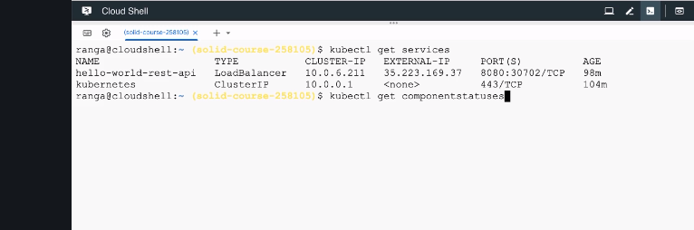

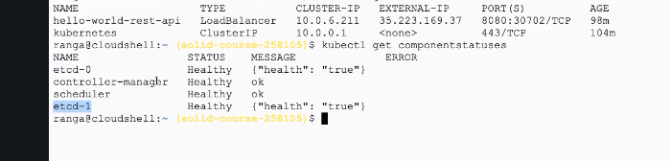

So, kubectl get componentstatuses. Get the spelling of the componentstatuses right. It's a little tough.

You can see all the component statuses for all the things that we have talked about.

You can see that we have two etcd databases: etcd-0 and etcd-1.

These are both healthy.

You can see the controller manage which is healthy.

You can see this scheduler which is healthy as well.

So, these are some of the components which are running as part of your

Kubernetes master node. In this step, we discussed the different components which are present in the master node and the worker nodes or just the nodes. We started this section with almost zero knowledge of Kubernetes and by the end of this section; I hope you've got some idea about all the important concepts in Kubernetes. I hope you are having a interesting journey and I'll see you in the next step. Until then, bye-bye.

**Understand Google Cloud Regions and Zones**

Check video